实验8 图及图的操作实验
班级： 23024051 姓名： 田永慧学号：20241576 专业： 计算机科学与技术
- 实验目的：
1、掌握图的基本概念和术语
2、掌握图的存储结构及创建算法。
3、掌握图的遍历算法（递归或非递归算法）。
- 实验内容：
1、图邻接矩阵存储结构表示及基本操作算法实现
（1）图的抽象数据类型描述
import java.util.*;

interface IGraph {
void CreateMatGraph(int[][] a, int n, int e);
void DispMatGraph();
}

（2）有向网（有向带权值的图）的邻接矩阵类的描述
class MathGraphClass implements IGraph {
final int INF = 65535;
int[][] edges;
int n, e;

@Override
public void CreateMatGraph(int[][] a, int n, int e) {
this.n = n;
this.e = e;
edges = new int[n][n];
for (int i = 0; i < n; i++) {
for (int j = 0; j < n; j++) {
edges[i][j] = a[i][j];
}
}
}

@Override
public void DispMatGraph() {
System.out.println("邻接矩阵：");
for (int i = 0; i < n; i++) {
for (int j = 0; j < n; j++) {
if (edges[i][j] == INF)
System.out.print("INF\t");
else
System.out.print(edges[i][j] + "\t");
}
System.out.println();
}
}
}
（3）邻接矩阵测试类

public class MathGraphClassDemo {
public static void main(String[] args) {
MathGraphClass m = new MathGraphClass();
int[][] a = new int[][] {{ 0, 8, INF, 5, INF}, { INF, 0, 3, INF, INF}, { INF, INF, 0, INF, 6}, { INF, INF, 9, 0, INF}, { INF, INF, INF, INF, 0}};
m.CreateMatGraph(a, 5, 5);
m.DispMatGraph();
}
}

测试结果粘贴如下：

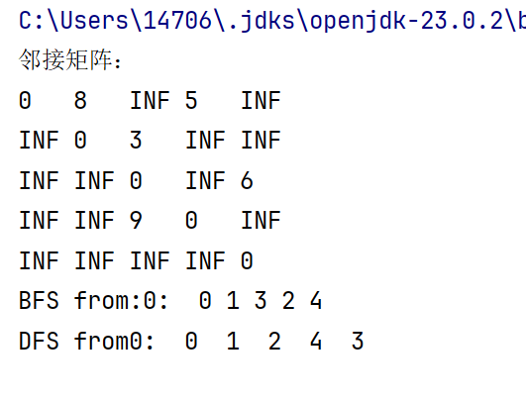

2、无向网（无向带权值的图）邻接表存储结构表示及基本操作算法实现
（1）顶点结点类
class VNode {
int data;
ArcNode firstArc;

public VNode(int data) {
this.data = data;
this.firstArc = null;
}
}

（2）边结点类
class ArcNode {
int adjvex;
int weight;
ArcNode nextArc;

public ArcNode(int adjvex, int weight) {
this.adjvex = adjvex;
this.weight = weight;
this.nextArc = null;
}
}
（3）邻接类
class AdjGraphClass {
VNode[] adjlist;
int n, e;
final int INF = 65535;

public void CreateAdjGraph(int[][] a, int n, int e) {
this.n = n;
this.e = e;
adjlist = new VNode[n];
for (int i = 0; i < n; i++) {
adjlist[i] = new VNode(i);
}

for (int i = 0; i < n; i++) {
for (int j = 0; j < n; j++) {
if (a[i][j] != 0 && a[i][j] != INF) {
ArcNode arc = new ArcNode(j, a[i][j]);
arc.nextArc = adjlist[i].firstArc;
adjlist[i].firstArc = arc;
}
}
}
}

public void DispAdjGraph() {
System.out.println("邻接表：");
for (int i = 0; i < n; i++) {
System.out.print("[" + i + "]");
ArcNode p = adjlist[i].firstArc;
while (p != null) {
System.out.print(" -> " + p.adjvex + "(" + p.weight + ")");
p = p.nextArc;
}
System.out.println();
}
}
}
（4）邻接表测试类实现
public class AdjGraphClassDemo {
public static void main(String[] args) {
AdjGraphClass adj = new AdjGraphClass();
int[][] a = new int[][] { { 0, 5, INF, 7, 2 }, { 5, 0, 3, 10, INF}, { INF, 3, 0, 3, 4 }, { 7, 10, 3, 0, 8 }, { 2, INF, 4, 8, 0 } };
adj.CreateAdjGraph(a, 5, 8);
adj.DispAdjGraph();
}
}

测试结果粘贴如下：

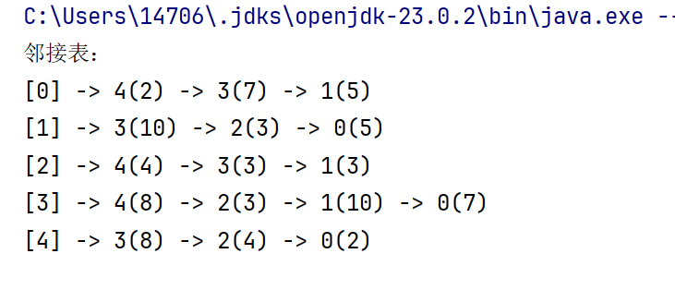
3、图的遍历递归算法
（1）深度优先遍历算法
连通图的深度优先遍历函数

private void dfsConnected(int v, boolean[] visited, List<Integer> component) {
visited[v] = true;
component.add(v);
for (int i = 0; i < n; i++) {
if (edges[v][i] != INF && edges[v][i] != 0 && !visited[i]) {
dfsConnected(i, visited, component);
}
}
}

图的深度优先遍历函数
public void dfsGraph() {
boolean[] visited = new boolean[n];
System.out.print("DFS遍历（整个图）: ");
for (int i = 0; i < n; i++) {
if (!visited[i]) {
List<Integer> component = new ArrayList<>();
dfsConnected(i, visited, component);
// 打印该连通分量
System.out.print("连通分量" + (i+1) + ": " + component + " ");
}
}
System.out.println();
}
测试结果粘贴如下：
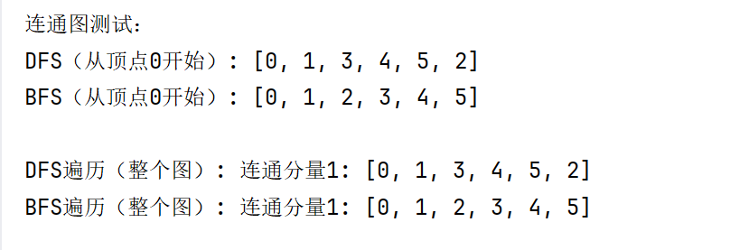

（2）广度优先遍历算法
连通图的广度优先遍历函数
private void bfsConnected(int start, boolean[] visited, List<Integer> component) {
Queue<Integer> queue = new LinkedList<>();
visited[start] = true;
queue.offer(start);
while (!queue.isEmpty()) {
int v = queue.poll();
component.add(v);
for (int i = 0; i < n; i++) {
if (edges[v][i] != INF && edges[v][i] != 0 && !visited[i]) {
visited[i] = true;
queue.offer(i);
}
}
}
}

图的广度优先遍历函数
public void bfsGraph() {
boolean[] visited = new boolean[n];
System.out.print("BFS遍历（整个图）: ");
for (int i = 0; i < n; i++) {
if (!visited[i]) {
List<Integer> component = new ArrayList<>();
bfsConnected(i, visited, component);
// 打印该连通分量
System.out.print("连通分量" + (i+1) + ": " + component + " ");
}
}
System.out.println();
}

测试结果粘贴如下：
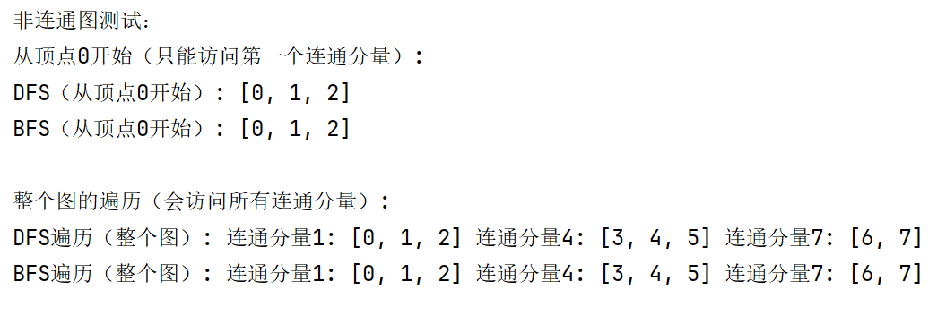

- 心得体会：（含上机中所遇问题的解决办法，所使用到的编程技巧、创新点及编程的心得）（至少选2个在算法设计或算法实现编码过程中遇到的问题及相应解决方案）

